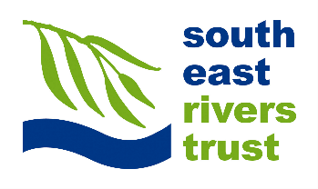**Safety Guidelines**

Guided Walk

These guidelines are here to help keep you and our other participants safe during our events. You must read these before taking part in the event with the South East Rivers Trust.

**Before the event:**

* Read the Safety Guidelines
* Dress appropriately for the weather on the day
* Wear sturdy, closed-toe shoes
* Ensure you eat, are hydrated before the event, and bring food and water if you like
* Let us know if you can no longer make it

**During the event:**

* Always stay with the group and remain within sight of event coordinator
* Take care when walking along the river bank and be aware of any uneven terrain or dog foul
* Report any accidents or injuries
* Please be aware and respect other park users by avoiding blocking any paths
* Respect the wildlife and river habitat
* Respect other participants and event coordinator during the event
* Ensure you wash your hands after the event and before eating or drinking

**Diseases and infections**

Please be aware that there is a low risk of contracting the following diseases from the river and green spaces. To mitigate the risk we ask for all open cuts to be covered, and to keep hands away from eyes, nose and mouth and hands washed after contact with river water and session.

If you get any flu-like symptoms in the three weeks following the event, please inform your doctor about the increased chance of Weil’s disease after working in/near a river and ask to be tested.

Leptospirosis (Weils Disease)- spread in the urine of infected animals – most commonly rats, mice, cows, pigs and dogs. More Info: <https://www.nhs.uk/conditions/leptospirosis/>

Lyme Disease- contracted from tick bites. More info: <https://www.nhs.uk/conditions/lyme-disease/>

Bacteria and Virus infections-contracted from sewage. More info: <https://www.sas.org.uk/water-quality/the-risks-of-mixing-with-sewage/>